**\*\*\*\*PUBLIC NOTICE\*\*\*\***

**CORINTH PARKS AND RECREATION BOARD SPECIAL**



**SESSION - CANCELLED**

**Wednesday, June 8, 2022 at 6:00 PM**

**Public Works | 1200 N. Corinth Street**

Due to a lack of quorum, the meeting has been cancelled. Posted on this 7th day of June 2022, at 5:00 P.M., on the bulletin board at Corinth City Hall.

Posted on this 7th day of June 2022, at 5:00 P.M., on the bulletin board at Corinth City Hall.

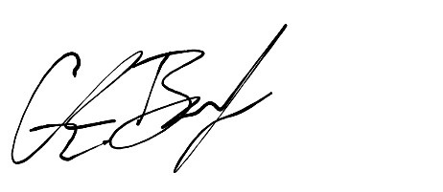

Glenn Barker

Director of Public Works

City of Corinth, Texas