PD DESIGN STATEMENT
(RESIDENTIAL PD PROJECT WORKSHEET/TEMPLATE)
Use for Single-Family and Multi-Family Projects

DIRECTIONS: Use outline as guide to organize information when creating PD Design Statement.

*Note that not all categories listed in Section 2 will be applicable to every project type, e.g., single-family versus multifamily. Adjust the worksheet to best suite your project.
**Reference PD Application Checklist or UDC Section 2.10.09.C.2.b. for complete list of required information for PD Design Statement and PD Concept Plan.

SECTION 1 - OVERVIEW

- PROJECT NAME/TITLE: (PROVIDE A UNIUQE NAME IDENTIFIER)

- LIST OF OWNERS/DEVELOPERS:

- PROJECT ACREAGE AND LOCATION: (INCLUDE TOTAL ACRES, NUMBER OF TRACTS/LOTS, LOCATION, ETC.)

- PROJECT OVERVIEW: (DESCRIBE PROJECT OVERVIEW AND WHAT TRYING TO ACHIEVE WITH PROJECT)

- PROJECT DESCRIPTION:
- PROVIDE NARRATIVE AND GIVE DETAILS ENOUGH TO JUSTIFY WHY YOU ARE REQUESTING TO REZONE THE SUBJECT PROPERTY
- DISCUSS WHY YOU CHOSE A SPECIFIC BASE ZONING DISTRICT
- DISCUSS WHY/HOW THE NEW PD DISTRICT WILL LEAD TO EXCEPTIONAL QUALITY AND INNOVATION FOR THE PROPOSED DESIGN.

SECTION 2 – PROJECT DESIGN (PROVIDE DETAILED JUSTIFICATION AND SUPPORTING DOCUMENTATION FOR EACH “SPECIAL PROVISION BEING PROPOSED” AND FOR EACH “DEPARTURE REQUESTED” BELOW)

- DEVELOPMENT REGULATIONS: (LIST ALL SPECIAL DEVELOPMENT REGULATIONS OR MODIFIED REGULATIONS AS WELL AS ANY SUBDIVISION WAIVERS BELOW)

The following “Development Regulations” represent special development regulations, and specific departures or modifications, as well as waivers from the regulations outlined in Unified Development Code (UDC) in order to permit the unique design and afford flexibility and innovation of design that require certain departures from the “based zoning” regulations to create the ________type____ project as presented in Exhibit __ - PD Concept Plan and other associated plans as presented in “Supporting Documents” contained in Appendix A.

- Permitted Use and Use Regulations. UD Section 2.07 shall apply. OR shall apply, except that, __________(LIST ALTERNATIVE USE STANDARDS HERE)____. DO YOU HAVE ADDITIONAL USES, PROHIBITED USES, OR SUP USES FOR YOUR NEW PD DISTRICT?

Justification:
- Dimensional Regulations. UDC Section 2.08.04 shall apply. OR shall apply, except that__________(LIST ALTERNATIVE STANDARDS HERE)____ and to allow for _______________________as defined in Table _____ below.

Justification:

Table _____ – Dimensional Requirements

Regulation: | ______ Base District: | Proposed Dimensional  Standards/Modifications:
Minimum Front Yard Setback
Minimum Side Yard Setback:
Interior Lot
Corner Lot
Minimum Rear Yard Setback
Minimum Lot Area
Maximum Density
Minimum Lot Width:
Minimum Lot Depth
Minimum Floor Area
Maximum Height (feet/stories)
Maximum Building Area (all buildings)
Other:

- Accessory Building and Uses. UDC Section 2.07.07 Accessary Building and Uses shall apply. OR shall apply, except that, ______(LIST ALTERNATIVE STANDARDS HERE)____.

Justification:

- Landscaping Regulations. UDC Section 2.09.01 Landscape Regulations shall apply. OR shall apply, except that, __________(LIST ALTERNATIVE STANDARDS HERE)____.

Justification:

- Tree Preservation. UDC Section 2.09.02 Tree Preservation regulations shall apply OR shall apply, except that, __________(LIST ALTERNATIVE STANDARDS HERE)____.

Justification:

- Vehicular Parking Regulations. UDC Section 2.09.03. Vehicular Parking Regulations shall apply. OR shall apply, except that, __________(LIST ALTERNATIVE STANDARDS HERE)____.

Reference Table __, below:

Table B – Parking Requirements (AS APPLICABLE)

Regulation: |  | ___Base Regulations by Use | Proposed Parking Standards/Modifications
Parking Standard:

Justification:

- Garages. (AS APPLICABLE TO SINGLE FAMILY RESIDENTIAL PROJECTS) UDC Section ____ shall apply except that, ___________(LIST ALTERNATIVE STANDARDS HERE)____.

- Garages, driveways, and parking. (AS APPLICABLE TO MULTIFAMILY RESIDENTIAL PROJECTS) UDC Section 2.04.07.C.5 requirement that “a minimum of seventy-five (75) percent of all apartments shall have a one-car enclosed garage, two hundred forty (240) square feet minimum, attached or detached, per dwelling unit”, shall apply. OR Shall apply, except that, __________(LIST SPECIAL STANDARDS HERE)____. Reference Table __, below:

Justification:

Table __- Garages. (AS APPLICABLE)
 | MF-__ Base District | Proposed  Garage Modification

- Building Façade Material Standards. UDC Section 2.09.04 Building Façade Material Standards shall apply. OR shall apply, except that, ___________________________(LIST ALTERNATIVE STANDARDS HERE)____.

Justification:

- Nonresidential Architectural Standards. UDC Section 2.09.06. shall apply and be in accordance with the design concepts outlined below: __________(LIST ALTERNATIVE STANDARDS HERE)____.

Justification:

- Residential Adjacency Standards. UDC Section __ Residential Adjacency Standards shall apply. OR shall apply, except that, __________(LIST ALTERNATIVE STANDARDS HERE)____.

Justification:

- Private Recreational Areas. (AS APPLICABLE TO MULTIFAMILY RESIDENTIAL PROJECTS - REFERENCE BASE ZONING DISTRICT. LIST AMENITITES AND DOCUMENT ASSOCIATED PERCENTAGE OF THE OVERALL GROSS COMPLEX – SHOW THIS INFORMATION ON PD CONCEPT PLAN AND CONCEPTUAL LANDSCAPE PLAN) UDC Section ______ Regulations shall apply where a minimum of 8% of the gross complex is required to be in the form of private recreation. Note that the requirements of this section, are in addition to the park dedication requirements within 3.05.10. Park and Trail Dedications for Residentially Zoned Property. To meet the Private Recreation requirements, the project includes the provision of _____________________________gross complex. The “private recreation areas” are shown on Exhibit___– _______________ in Appendix A.

Justification:

- Park and Trail Land Dedication. (AS APPLICABLE TO RESIDENTIALLY ZONED LAND CONSIDER CREATIVE WAYS TO COMBINE THIS REQUIREMENTS WITH PROTECTED TREE PRESERVATION REQUIREMENTS) UDC Section 3.05.10 requires that Park and Trail dedication for Residentially Zoned Property to be provided at a rate of 1 acre per/50 DU and/or fees-in-lieu-of (or combination shall apply, except that, ___________________(LIST ALTERNATIVE STANDARDS HERE)____.

Justification:

- Screening of Outdoor Waste Storage for Nonresidential, Single-Family Attached, and Multi-Family Residential Properties. UDC Section 4.02.13 shall apply. OR shall apply, except that, __________(LIST ALTERNATIVE STANDARDS HERE)____.

Justification:

- Lighting and Glare Regulations. UDC Section 2.09.07. shall apply. OR shall apply, except that, __________(LIST ALTERNATIVE STANDARDS HERE)____.

Justification:

- Sign Regulations. UDC Section 4.01 shall apply. OR shall apply, except that, __________(LIST ALTERNATIVE STANDARDS HERE)____.

Justification:

- Fence and Screening Regulations. UDC Section 4.02. shall apply. OR shall apply, except that, __________(LIST SPECIAL STANDARDS HERE)____.

Justification:

- Other. (LIST ADDITIONAL UDC SECTIONS HERE WHERE OTHER WAIVERS, MODIFICATIONS, SPECIAL PROVISIONS/ALTERNATIVE STANDARDES, ARE BEING REQUESTED)
  - Street Design
  - Stormwater Detention Basin Design
  - Conditional Development Standards for uses
  - Other

- OTHER DEVELOPMENT CONSIDERATIONS:

- Phasing. (EXPLAIN DETAILS HERE____. Reference Exhibit ___.)
- Impacts. (EXPLAIN DETAILS BELOW & PROVIDE EXHIBITS AS NECESSARY)
- Traffic Impact Assessment _________________
- Drainage/Stormwater Management __________________
- Floodplain/Wetlands
- Detention required for sites over 1 acre
- Utilities – Discuss utility lines and services to be installed (identify lines/services to be dedicated to public and which will remain private)
- Other __________________
- Other __________________

SECTION 3 - BACKGROUND INFORMATION

- Existing Site Conditions. (DESCRIBE SITE CONDITIONS HERE – ADDRESS ITEMS LISTED IN THE PD APPLICATION CHECKLIST. DISCUSS UTILITY LINES AND SERVICES TO BE INSTALLED AND TO BE DEDIDCATED/REMAIN PRIVATE – RECOMMEND INCLUDING A STATEMENT OF ADEQUACY TO BE SERVICED HERE TO AND INCLUDE SUPPORTING DOCUMENTATION AS AN EXHIBITS/ATTACHMENT)

The site is currently______________________ ______________. Reference Exhibit __ - Existing Site Conditions (Aerial with Project Layout Overlay)

Describe and discuss all topics that apply to the subject site:
- Street boundaries
- Surrounding properties (uses)
- Tree cover/Wetlands/Streams/Floodplain
- Drainage
- Existing easements
- Existing lift stations/pump stations/etc.
- Existing signage/buildings/etc.
- Existing site access
- Other – Other factors that may be unique to the site e.g., A statement of utilities, adequacy of utilities to serve site, traffic related impacts addressed, etc. How will your project be served and impact existing situation What are your proposed remedies if impacts are identified? etc.

- Current Zoning. (DESCRIBE EXISITING ZONING HERE)

The site is currently zoned _________________ which permits a range of uses by right including among ____________________________________, etc.

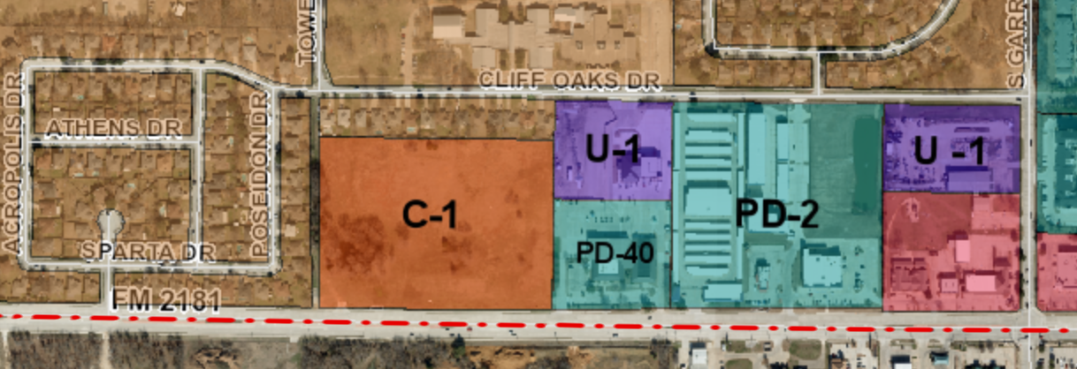
Source: Source: Corinth GIS Zoning Map

The existing zoning on the subject site permits the following:

Existing C-1 Zoning Dimensional Regulations:
Minimum Front Yard Setback
Minimum Side Yard Setback:
Interior Lot
Corner Lot
Minimum Rear Yard Setback
Minimum Lot Area
Maximum Density
Minimum Lot Width:
Minimum Lot Depth
Minimum Floor Area
Maximum Height (feet/stories)
Maximum Building Area (all buildings)
Other:

- Future Land Use. (DESCRIBE WHAT IS ENVISIONED FOR THE SUBJECT SITE – HOW DOES THE FUTURE LAND USE FURTHER OR SUPPORT YOUR REZONING REQUEST – INCLUDE AN EXIBIT)

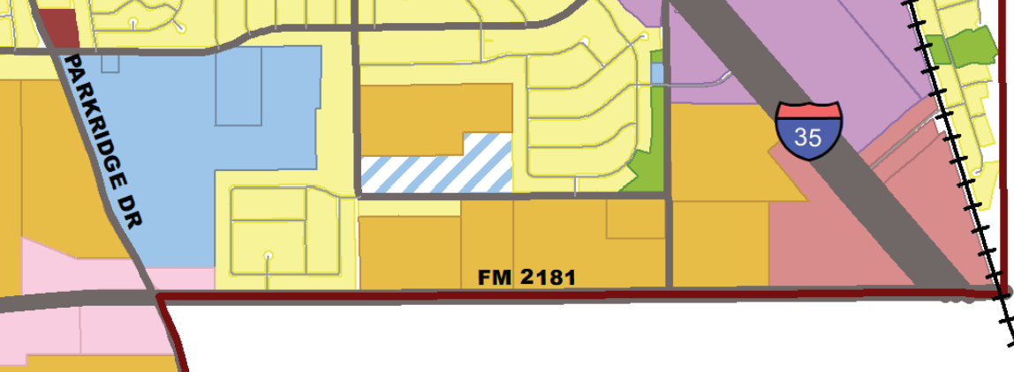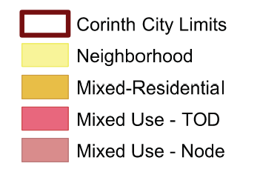
Source: Envision Corinth 2040 Comprehensive Plan (Adopted July 2020)

- Strategic Focus Areas. (DETERMINE WHETHER OR NOT THE SUBJECT SITE SHOWN WITHIN THE BOUNDARIES OF “STRATEGIC FOCUS AREAS” (AS APPLICABLE))

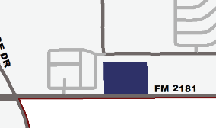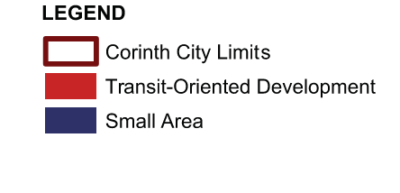
Source: Envision Corinth 2040 Comprehensive Plan-Stratigic Focus Area (Adopted July 2020)

- Scenarios. (DESCRIBE HOW THESE SCENARIOS AFFECT/FURTHER YOUR PROJECT HERE (AS APPLICABLE)

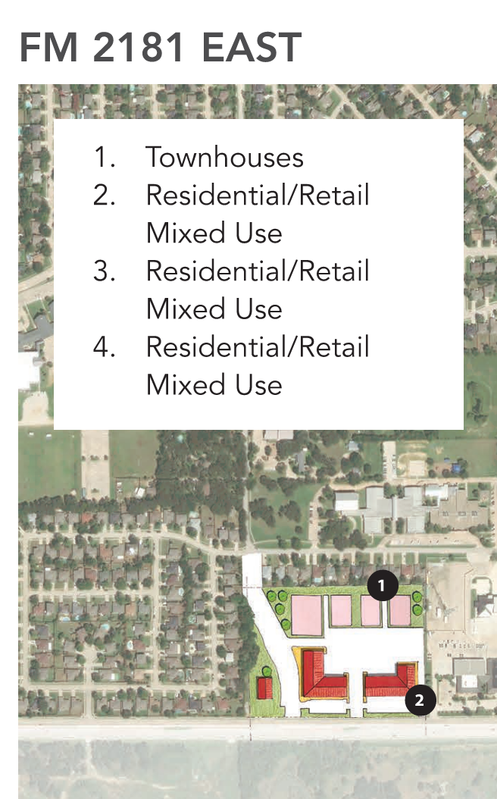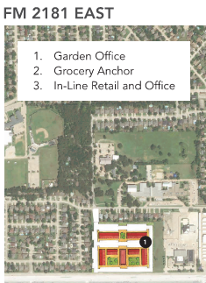
Source: Envision Corinth 2040 Comprehensive Plan (Adopted July 2020)

- Mobility – Master Thoroughfare Plan. (DESCRIBE MOBILITY CONCEPTS THAT ARE IDENTIFIED FOR YOUR PROJECT HERE (AS APPLICABLE)

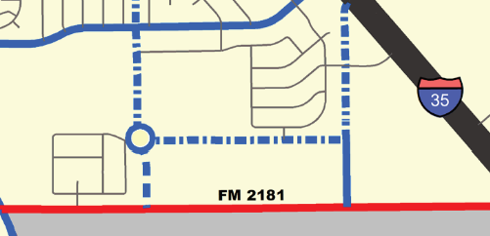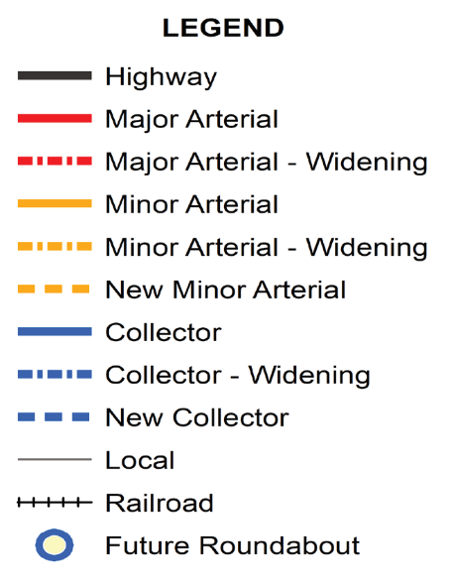
Source: Envision Corinth 2040 Comprehensive Plan - Master Thoroughfare Plan (Adopted July 2020)

- Mobility – Active Transportation Plan. (DESCRIBE HOW MOBILITY CONCEPTS AFFECT YOUR PROJECT HERE (AS APPLICABLE)

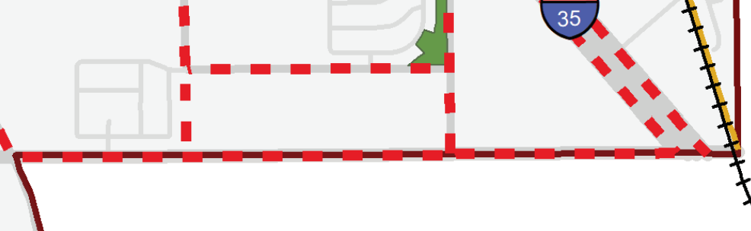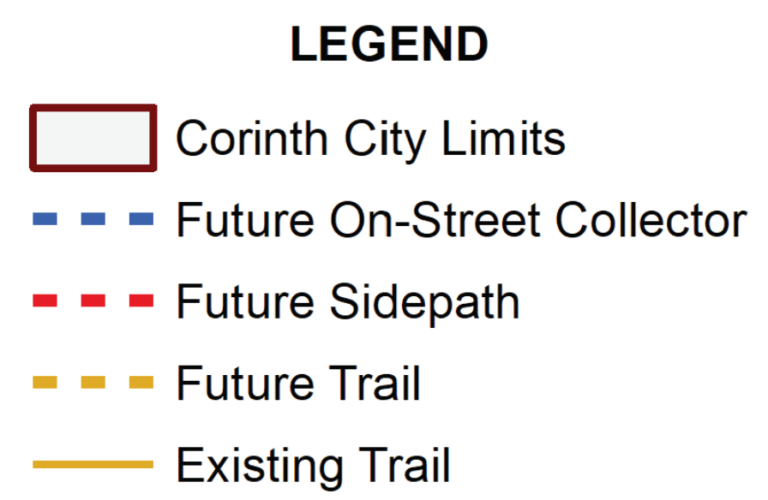
Sidepath on Tower Ridge Drive extension (south) and FM2181
Source: Envision Corinth 2040 Comprehensive Plan (Adopted July 2020)

- PARK, RECREATION AND OPEN SPACE MASTER PLAN (DESCRIBE WHAT IS ENVISIONED FOR THE SUBJECT SITE WITH REGARD TO PARKS AND RECREATION – HOW DOES THE PARK, RECREATION, AND OPEN SPACE PLAN FURTHER OR SUPPORT YOUR REZONING REQUEST – INCLUDE AN EXIBIT)

Source: Envision Corinth 2040 Park, Recreation and Open Space Plan (Adopted September 2020)

SECTION 4 - SUPPORTING APPLICATION DOCUMENTS (PROVIDE EXHIBITS TO SUPPORT REVIEW OF PROPOSED PROJECT TYPE)
- Exhibit A – Legal description (Include an overall description for acreage being rezoned)
- Exhibit B – Proposed Zoning Map Change (e.g., C-1 to PD with base zoning district of ___)
- Exhibit C – PD Concept Plan
- Exhibit D – Existing Site Conditions (include an aerial with project layout overlay)
- Exhibit E – Conceptual Landscape Plan
- Exhibit F – Elevations
- Exhibit G – Parking Study/Comparisons Chart
- Exhibit H – Phasing Plan
- Exhibit I – Traffic Impact Assessment
- Exhibit J – Other
- Exhibit K – Other

